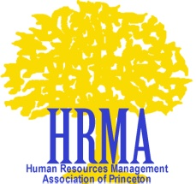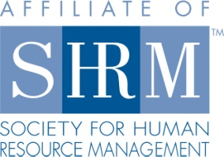

release for posting of resumes by hrma-NJ
For valuable consideration and intending to be legally bound, I hereby irrevocably consent to and authorize the posting of my resume on the website of the Human Resources Management Association of Princeton (“HRMA”), for any lawful purpose whatsoever, without any compensation to me. I further hereby release and discharge the HRMA, its officers, Board members, agents and assigns from any and all claims and demands arising out of or in connection with the posting of my resume on the HRMA website.

Signature Please Print Name

Dated E-mail Address

Important Information – Please Note:

The posting of resumes on HRMA-NJ’s web site is a service provided by HRMA-NJ to its In-Transition community. Resumes are accessible via password protection by HRMA-NJ members only. No resume will be posted without expressed permission by its owner, as given above. This form must be returned to HRMA-NJ with an original signature; photocopies or electronic forms will not be accepted. Please mail this form to HRMA PO Box 7001, Princeton, NJ 08540. Once this form is received, your resume will be posted.

The resume will be removed from the website upon the written request (email is acceptable) of the resume owner; or at the conclusion of the Program Year in which it is posted (Our Program Year is July 1 – June 30. Therefore, if a resume is posted in November 2011, it will be removed on or around June 30, 2012).

