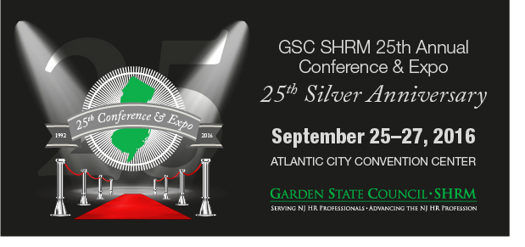

To: All HR Professionals
What: Register now for the biggest educational and networking event in NJ! Don’t miss this milestone event – The 25th Silver Anniversary GSC-SHRM Conference & Expo.
How: www.gscshrmconference.org Register Now!
Why: Breakout sessions – 70 with SHRM and HRCI Recertification Credits
Sponsors & Exhibitors – 60+ providing outstanding services and solutions
Keynote Speakers

Sunday’s Keynote:
Jon Petz, CSP
Author – Significance… in Simple Moments

Monday’s Keynote:
Panel of Chief Human Resources Officers
On Leadership, Gender and More: Confronting the Issues with Solutions
Susan Meisinger, China Gorman, Cheryl Bucci, Bernadette Palumbo, and Maryanne Spatola

Tuesday’s Keynote:
Nikki Johnson-Huston, Esq. Speaker, Attorney, Advocate
From Homeless to Lawyer, One Woman’s Amazing Journey

Vendors and Suppliers: Some booth and sponsorship opportunities still available – market to 500 HR & Conference Attendees. Contact Sponsor Chair Stewart Feller at
Ph: 201-921-6190 or e-mail him at tdboy@optonline.net.

